10/01/2022 10:13 20211129_092616.jpg

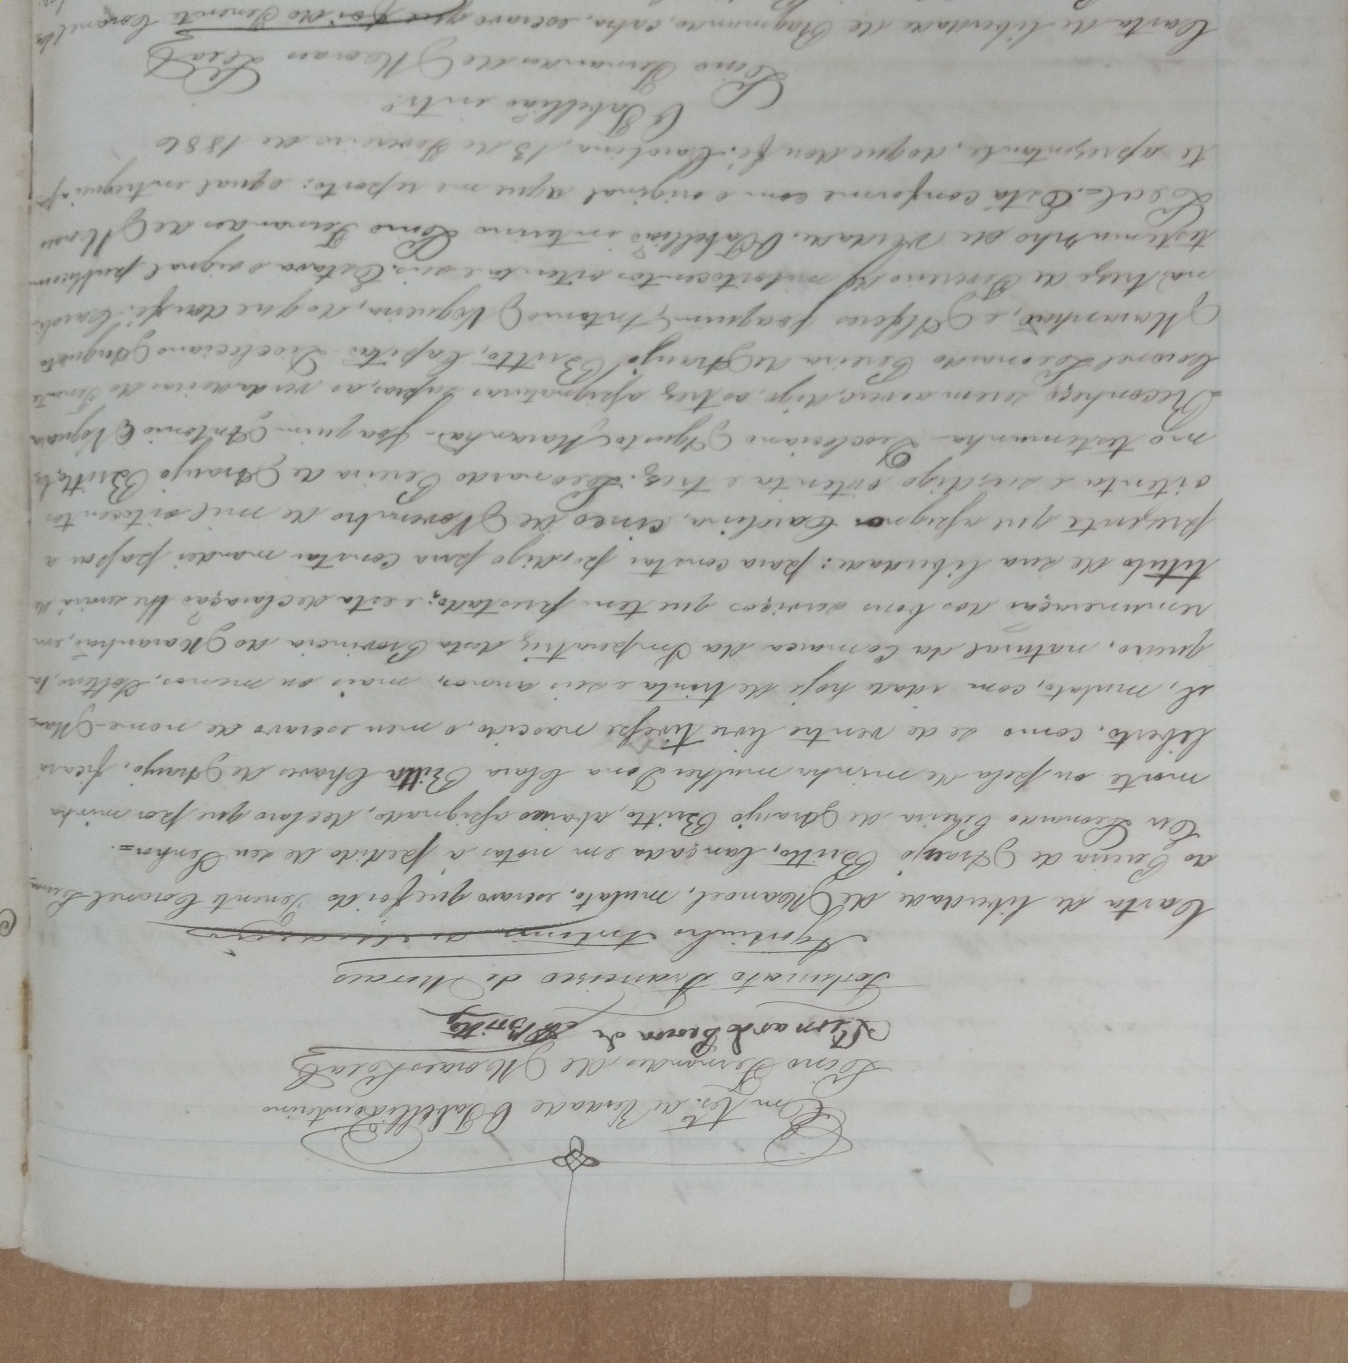

https://mail.google.com/mail/u/0/?tab=rm#inbox/QgrcJHsbjCZRqRxrZqlVqJqTqFVfNSnXQwQ?projector=1&messagePartId=0.1 1/1